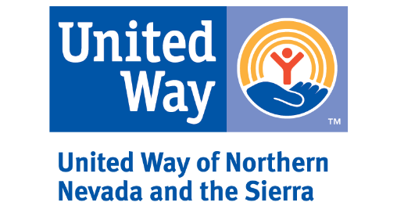

Request for Proposal – Cover Sheet
Is your organization(s) a 501(c)(3)? Yes No

Have you been in operation for a minimum of two (2) years? Yes No

Do you currently meet the Better Business Bureau’s Wise Give
Alliance standards for Nonprofits? Yes No

If you answered no to any of the above questions, STOP here. You are not eligible to apply for funding. If you answered yes to all the questions, please continue.

If this is a partnership of organizations applying, list the names of all the organizations within the partnership:

Please list the names and contact information for all staff members of the applying organization(s) who are responsible for the proposed program.
Contact Person for the RFP | All questions and correspondence regarding the RFP will be directed to this person.
Contact’s Name
Contact’s Title
Contact’s Telephone Number
Contact’s Email Address

Organization
Organization’s Name
Street Address

Mailing Address

Telephone Number
Fax Number
Website Address
Organization Executive Director/CEO
Name
Title
Telephone Number
Email Address

Primary Program Contact | If funded, this person will serve as the primary contact for the program throughout the grant cycle.
Name
Title
Telephone Number
Email Address

Additional Program Contact | If funded, this person supports the program, but is not the primary contact for it.
Name
Title
Telephone Number
Email Address
What is their role with this program?

Additional Program Contact | If funded, this person supports the program, but is not the primary contact for it.
Name
Title
Telephone Number
Email Address
What is their role with this program?

Additional Program Contact | If funded, this person supports the program, but is not the primary contact for it.
Name
Title
Telephone Number
Email Address
What is their role with this program?

Where you a UWNNS Funded Partner in the 2015 – 2018, 2018 – 2020, or 2020 – 2021 grant cycles? Yes No

Is this a new program (for you), or an existing program?

