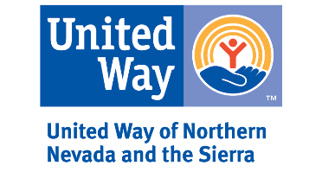
2020 Microgrant Application
Section 1: Organization Information

Legal Name of Nonprofit Organization:
Federal Employer Identification Number (FEIN):
DUNS:
Year Organization Established:
Physical Address:
Mailing Address:
Place of Performance (where services are delivered):
Physical Address for Place of Performance:
Agency Website
Please indicate counties served. | Carson City Churchill Douglas Elko Eureka Humboldt Lander Lyon Mineral Pershing Storey Washoe White Pine

The following must be completed in order to assist with the consideration of funding:
- Provide a description of your organization; this includes explaining your organization’s history, vision, mission, services, and programs.

- UWNNS has a specific interest in providing support to organizations serving underserved populations. Please describe your target audience.

- Although not required, please share what capacity your agency has to serve individuals who are Spanish speaking only, e.g. do you have someone on staff who can speak to clients who may come in?

- How has the COVID-19 pandemic impacted your budget, fundraising, and revenue?

- How much money has your organization lost because of the COVID-19 pandemic?
(Updated as of 8/4/2020)

- How has the COVID-19 pandemic impacted your organization’s operations and processes?

2020 Microgrant Application
Section 2: Contact Information

Please provide the following contact information. The Application Contact is the person to whom communication regarding the application should be directed.
Organization Director/CEO Name:
Organization Director’s Title
Organization Director Telephone:
Organization Director Email Address:
Application Contact Name:
Application Contact Title:
Application Contact Telephone:
Application Contact Email Address:

2020 Microgrant Application
Section 3: Proposal Information

TOTAL Amount Requested | $

- How is your organization proposing to spend these funds?

- What is your anticipated timeline for this proposal?

- Please include an outline of proposed expenses.

- Why does your organization need this funding? If this is a new expense, please indicate that this is a new expense.

- What outcomes do you anticipate achieving with this funding?

- How will this funding help your organization and larger community achieve sustainability during the COVID-19 pandemic?

- How will you acknowledge funding from UWNNS?

- If applicable, please describe any support you might need from UWNNS, e.g. additional volunteer support.

2020 Microgrant Application
Section 4: Required Attachments

Submit the following required attachments with your application:

- Copy of your 501(c) (3) tax-exempt status letter for your organization
- A completed and signed W-9 form.
- Copy of most recently approved Operating Budget
- A roster of the nonprofit organization’s Board of Directors
- A completed and signed Patriot Act form.

