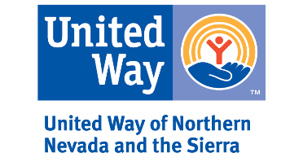
UWNNS 2020 Microgrant

Description and Guidelines

Thank you for your interest in United Way of Northern Nevada and the Sierra’s Microgrant Program. Over the past few months, United Way of Northern Nevada and the Sierra (UWNNS) has identified the need for capacity building for small non-profits who have been negatively affected by the COVID-19 pandemic; this includes, but is not limited to, canceling traditional fundraisers, normal funders refocusing their efforts, and expenses accrued due to necessary changes as a result of the COVID-19 pandemic. This can be accomplished by either covering current capacity needs or launching new initiatives in response to the COVID-19 pandemic.

This funding is for 501(c)(3) nonprofit organizations with annual budgets of less than $1 million that focus on either education or human services. Eligible nonprofit organizations must be based in and serve in Carson City or one of the following Nevada counties: Churchill, Douglas, Elko, Eureka, Humboldt, Lander, Lyon, Mineral, Pershing, Storey, Washoe, and White Pine.

The purpose of this funding is to help eligible nonprofit organizations maintain/build capacity so that they can continue to deliver services and programs during the COVID-19 pandemic. Grants will be awarded for no more than $5,000 per organization. The spending period for these microgrants is September 1, 2020 to November 30, 2020. (Updated as of 8/4/2020).

Applying for a Microgrant

Once you have reviewed the Microgrant Program Description and Guidelines and determined that your organization is eligible, please complete the attached application. The application consists of 4 sections:

- Organization Information
- Contact Information
- Proposal Information
- Required Attachments

Please send the completed application and attachments to communityimpact@uwnns.org. If you have any questions or need assistance completing your application, please contact Stephane Rector via email at communityimpact@uwnns.org.

The deadline for applications is Friday, August 14, 2020 by noon.

Completion of an application is NOT a guarantee of funding.

The United Way of Northern Nevada and the Sierra Microgrant Committee, made up of community volunteers, will review your application. UWNNS will be in contact with you if any additional information is necessary.

