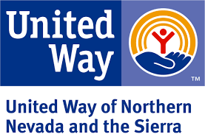
Final Report
Emergency Assistance Fund
United Way of Northern Nevada and the Sierra
Spending Period: April 1, 2020 to September 30, 2020

Mail completed Final Report and all documentation to Stephane Rector, United Way of Northern Nevada and the Sierra, 639 Isbell Rd., Ste 460, Reno, NV, 89509. Documentation can include summary spreadsheets, schedules, receipt/invoices, verification forms, and proof of payment. Refer to the Emergency Assistance Fund for a list of required documents for each service category.

Agency Name:

Agency Mailing Address:
Person Completing Report:

 | Total Awarded | Total Spent | Difference | # Services | # Households | # Adults | # Children
Served Meals
Other Food
Mass Shelter
Other Shelter
Rent/Mortgage Assistance
Utilities Assistance

Signature, Agency Representative Date

By signing this report, United Way of Northern Nevada and the Sierra is satisfied that the agency has expended funds in a timely manner and within the stated eligible costs of this program.

Signature, United Way of Northern Nevada and the Sierra Date

