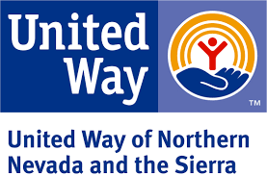
Interim Report and 2nd Payment Request
Emergency Assistance Fund
United Way of Northern Nevada and the Sierra
Spending Period: April 1, 2020 to June 30, 2020

Agency Name:

Agency Mailing Address:
Person Completing Report:
This form must be completed and signed when your agency is requesting the second portion of its allocation. Your agency must submit your back up documentation for the first payment before second payments can be made. Requests for second payments should be submitted to United Way of Northern Nevada and the Sierra before your agency’s first payment is exhausted.
Report on the amount spent from your LRO's first payment.
Category | Allocation Expenditures
- Served Meals | $
- Other Food | $
- Mass Shelter | $
- Other Shelter | $
- Rent/Mortgage Assistance | $
- Utilities Assistance | $
- Unexpended Funds to Date | $
- TOTAL of Funds Received to Date (A+B+C+D+E+F+G) | $

Signature, Agency Representative Date

The above agency is in need of the second portion of its award. By signing this report, United Way of Northern Nevada and the Sierra is satisfied that the agency has expended funds in a timely manner and within the stated eligible costs of this program.

Signature, United Way of Northern Nevada and the Sierra Date

Email signed report to communityimpact@uwnns.org or
mail to 639 Isbell Road, Suite 460; Reno, NV 89509.

