SAMPLE FOOD VOUCHER
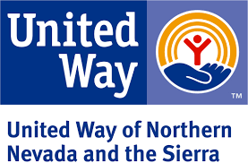

LRO’s Name and Address

, , please allow
(Store Name) (Address)

to purchase up to $ of food items only.
(Client’s/Purchaser’s Name) (Dollar Amount)

The will reimburse you upon receipt of a voucher signed by
(LRO’s name)

client/purchaser and store representative with an itemized register tape attached.

No alcohol. No lottery tickets. No cigarettes.
No non-food items (except diapers and feminine hygiene items, if marked below). No cash back.

Diapers: YES
Feminine Hygiene Items: YES
NO NO

$
(Actual Amount Purchased)

(Signature, Purchaser/Client) (Date - month/day/year)

(Signature, Store Representative) (Date - month/day/year)

(Signature, LRO Representative) (Date - month/day/year)

Note: When submitting documentation to UWNNS, if the voucher is filled out completely and all 3 signatures are present and dated, an itemized food receipt is not required. If not filled out completely or all 3 signatures are not present, then the itemized food receipts must be included with the voucher.)

